Welcome To The

Transforming Communication Seminar


Keys To Success

1. Know Your Outcome
2. Take Action
3. Notice Results (Sensory Acuity)
4. Flexibility To Adjust Based On Results
5. State Of Excellence
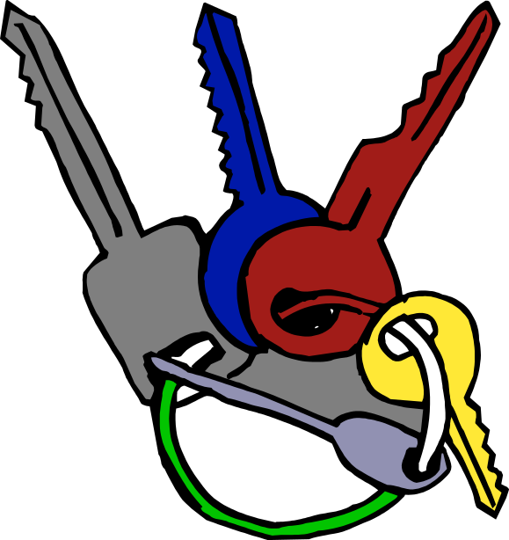
Presuppositions of NLP

- The map is not the territory
- Change is a result of adding more choices and enabling use of resources
- “Resistance” = lack of rapport
- “Failure” = feedback
- Mind and body are a system
- Change in one part of a system affects all parts (ecology)
- The response you get is the "meaning" of a communication

The Goals Of
Transforming Communication

1. Set Achievable Goals
2. Quickly create the state of mind you need to communicate
3. Build Rapport Easily
4. Select Communication Skills
5. Help Others Solve Problems
6. Assert Your Needs  7. Resolve Conflicts  8. Influence Others | 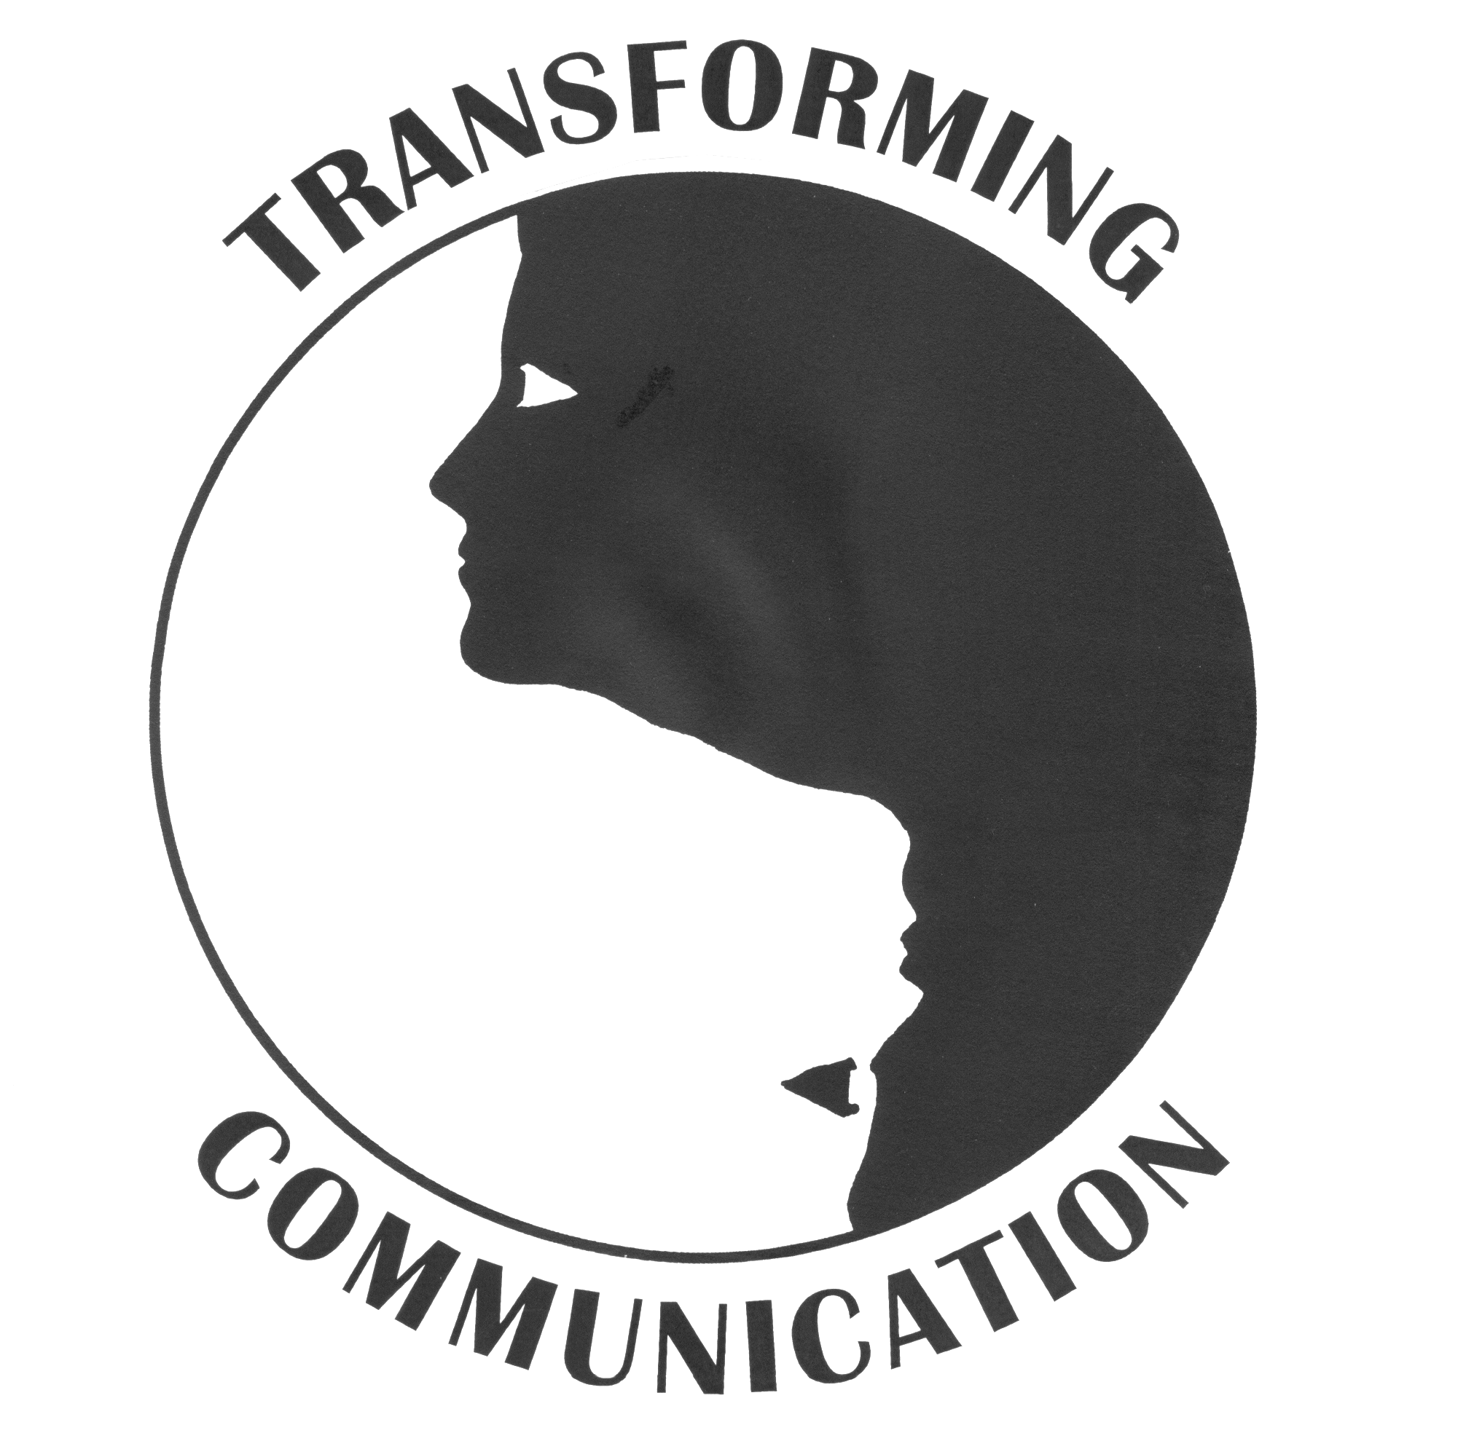

Goalsetting
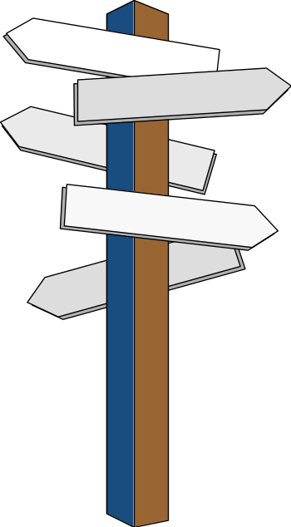
Sensory Specific
Positive
Ecological
Choice Increasing
Initiated by Self
First Step Identified
Your Resources Identified
Rapport
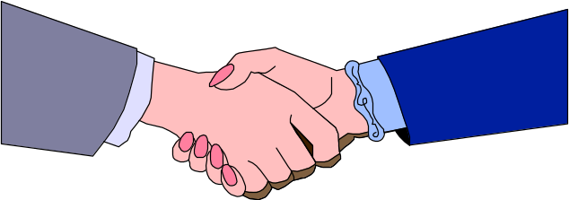

Auditory
Match voice speed, volume,
tone, timbre, word choice

Visual
Match gestures and posture

Kinesthetic
Match breathing

Anchoring


A hand gesture, word, image etc that reconnects you to a state from a previous experience
- Strong State
- Precise Timing
- Unique gesture/word/image
- Repeatable when needed

I observe all the other person’s “Behaviours”
(what I can see/hear/touch)
as if through a window …



“Problem Ownership”
My Line of Happiness

No Problem Area
(I’m Happy With The Person’s Behaviour)
Line Goes Up And Down

I Own A Problem
(I’m Not Happy About
The Person’s Behaviour)

Problem Ownership

The Other’s Line of Happiness

Other Is OK Other Not OK
Both Happy No Problem | My Line of Happiness  I’m OK I’m Not OK  Other Person Owns A Problem
I Own A Problem | Both Of Us Own A Problem (Conflict)

The Aim Of

Transforming Communication

No Problem

Area

Problem Ownership

A Basis For Choosing Skills

No Problem  Both Happy:  Rapport Skills | Other Owns A Problem:  Helping  Skills
I Own A Problem:  Assertive  Skills | Both Own Problem:  Conflict Resolution

Thomas Gordon’s List Of

Roadblocks
- Ordering
- Threatening
- Moralising
- Advising
- Lecturing
- Blaming
- Labelling
- Analysing
- Praising
10. Reassuring
- Probing
12. Diverting
Attending

- Closeness and Height
- Facing
- Open Body Gestures
- Mirroring
- Nodding Head
- Eyes Available
- No Distractions
- Minimal Encouragers

Learning Stages

Unconsciously
Skilled

Consciously

Skilled

Consciously
Unskilled

Unconsciously
Unskilled

???
Questions

Closed  How many?  Which one?  Did you?  Didn’t you? | Open  How?  What like?  Tell me…  Why

A Model Of

Communication

Send Code Receive

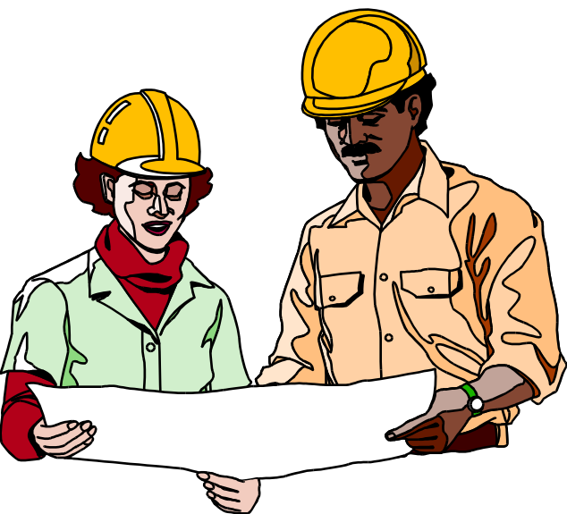

Successful Decoding

When

Hungry is Hungry

Dinner?

Unsuccessful Decoding

When

Hungry is Angry!

Dinner?

Reflective Listening
As Feedback

Are you angry?

When

Hungry is Angry!

Dinner?

NLP Eye Accessing Cues

Visual Visual

Construct Recall
Auditory  Construct | 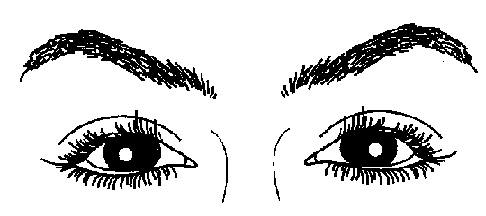 | Auditory  Recall

Kinesthetic Auditory

Digital

Right Left

Visual
“So it looks
to you like…”

V

K A

Kinesthetic Auditory
“So it feels “So it sounds
to you like…” to you as if…”
Helping Skills

- Attending / Rapport Skills
- Open Questions
- Reflective Listening
- Matching Sensory Systems


My Aims When I Own A Problem

- Get change
- Prevent similar problems
- Preserve relationship
- Preserve other’s self esteem

I Messages

- Sensory Specific Behaviour
“When… happens…”

- Concrete Effects
“…The result for me is…”

- Feeling State
“…and I feel…”
The Anger

Volcano

Angry

Frustrated
Confused
Exhausted
Resentful
Fearful
Hurt
etc…
I Messages,
Reflective Listening, And Emotional Temperature

Emotional
Temper-ature of Person Receiving The I Message

IM RL IM RL

The Two Step

A. Person 1 sends an I Message and steps down
② ①

B. Person 2

“Resists”

C. Person 1
Reflects
② ①

Until Person 2 Nods

D. Person 1 Restates I Message

The Two Step
1  I . . . | But . . .  2
So You. . .  3 | OK, Well I . . .  4
Check if result is …

Problem Solved
- Conflict of Needs
- Conflict of Values

Conflict Resolution

I Win, Compromise You Win,
You Both Give In I Lose
Lose

Win-Win
Solution

My Basic Your Basic
Goal/Need Goal/Need

Win-Win Steps

- Set The Stage: Partnership
- Define Conflict In Terms Of
Basic Goals and Needs
- Brainstorm Solutions
- Check Solutions
- Choose Best Solution
- Plan And Take Action
- 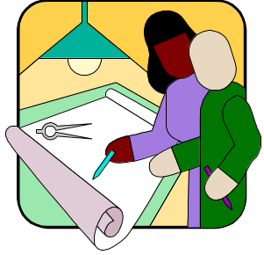Evaluate

Partnership

We are in this together

This is only one aspect of our relationship

We can find a win-win solution

Disagreeing is OK

In the past we… so now lets…


When To Use Power?
-Rules Out Of Your Control
-Your Own Need Is Overriding
-Obvious Danger To Person
-No Time To Negotiate
-Person Unable To Negotiate

Minimising The Effects
- Use Minimum Force
- Explain Reason You Used Power, And Restate Intention
- Use Reflective Listening
- Plan For Future Times

Modelling

- Consistency where it matters to the other person
- Demonstrate that it works for you (you enjoy it)
- Rapport

Metaphor

1. Rapport
2. Sensory detail
3. Positive conclusion
4. Action steps clear
Consulting
- Know The Facts Well
- Get Hired
- Use I Messages
- Reflective Listen
- Leave The Other To Decide


Build Rapport

I’m OK I Own Problem

Other Other Owns I Message

Is OK Problem And Reflect

I’m OK Conflict Solved
Helping Both Agree One Of Us
Skills It Affects Us Sees It As
= Conflict Of ‘My Life’
Needs = Values

Win-Win

Shared Model Consult Change
Values Relat.
Values
Conflict
High Risk To
Relationship

Choices
Use Power
Modify Relationship
Win-Win For Behaviours
Shared Values
Modelling
Consulting
Metaphor

Influence

Congruently Modify Self
Low Risk To
Relationship

The Brain: Sensory Areas

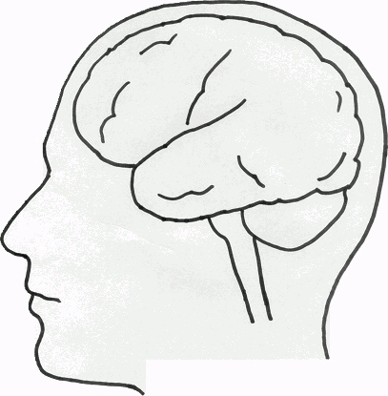
Kinesthetic
Visual
Auditory

Resource Anchoring
- Establish rapport
- Choose gesture; Pretest time you want to change. "You'd know if that changed, wouldn't you?"
- Associate into resourceful memory, see, hear, feel it
- Use gesture once can feel state
- Break state
- Test anchor. Use gesture, check

- Use gesture and think of time they’ll want it. Check that it changes how they feel.
Inner Smile

Physiology: smile, back straight
Anchoring: love, caring
Submodality Shift: 5 colours
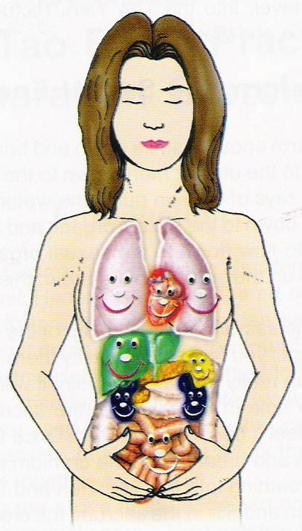
Reframing…

anger – kind to self
haste – joy & love
stuck – openness
sadness – knowing
what’s right for
you
fear – gentleness

The Brain: An NLP Model
The Outside World
(The Territory)

Maps: Kinesthetic
Auditory & Visual
Internal Representations

State of Mind

Physiology
Behaviours

